EXAM SUMMARY

SUPPLEMENTAL HOMELAND SECURITY
Undergraduate and Graduate Academic Degree Levels

July 2020
Written & Delivered By:

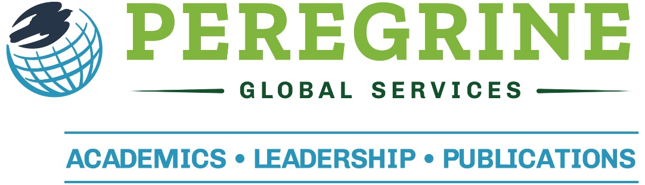

SUPPLEMENTAL HOMELAND SECURITY
EXAM SUMMARY
Introduction
Peregrine Academic Services, the higher education division of Peregrine Global Services, provides assessment services for performing direct assessment of learning outcomes for several academic disciplines. The online exams are used to evaluate retained student knowledge in relation to the academic program’s learning outcomes.
This document outlines the Homeland Security (HLS) topics which may be used to complement the Business Administration or Public Administration comprehensive exams. These advanced topics may be used for both undergraduate and graduate students.
These advanced HLS topics are designed for use by U.S.-based schools and programs.
Validity and Reliability
Peregrine Academic Services places a high priority on ensuring the validity and reliability of the assessment services. These practices begin at the design stage and continue through beta-testing, and with ongoing regularly scheduled quality reviews. A summary of these approaches is provided at the end of this document. For additional information regarding the reliability process, please refer to the following peer-reviewed article:
Oedekoven, O. O., Napolitano, M., Lemmon, J., & Zaiontz, C. (2019). Determining test bank reliability. Transnational Journal of Business, 4(Summer), 63-74.
Testing Process
The exams include 10 questions for each exam topic. Each exam is unique as questions are selected at random from the test bank of over 200 questions per topic. Institutions select the topics to be included in the exam to align with the learning outcomes and program curriculum.

Available Exam Topics
The specific topics for this assessment service that are available for use with a customized assessment are:
- Investigation
- Policy and Law
- Risk Management
- Terrorism
Subjects and Example Questions
The following pages include the specific subjects included with the topics along with example questions for the topic. These specific questions have been inactivated within the test bank and are shown in this document only to illustrate the types of questions that are presented to learners.
Test bank questions are written and proofed by terminally degreed, subject matter experts from accredited institutions who have teaching experience with the specific discipline. The criteria for a test bank question include:
- Test questions may be questions or (incomplete) statements.
- All multiple-choice format with 4 possible responses and only one correct response.
- All responses must be plausible and not misleading.
- “All of the Above” (or similar) or “None of the Above” or “A & C” responses are not used.
- All incorrect responses are assigned Response Distractors:
Response Distractor Student’s response indicates they…
Fact-based error …do not know the fact(s).
Concept-based error …misunderstood the concept.
Conclusion-base error …reached an incorrect conclusion.
Interpretation-based error …incorrectly interpreted the question.
Calculation-based error …made an error with a math-related calculation.

Investigation
Subjects:
- Constitutional Principles
- Crisis Management
- History
- Law Enforcement
- Legal Concepts

Example Questions:
The 9-11 commission identified the need for greater_____ as a key component in the prevention of future terrorism incidents.
- information sharing
- law enforcement powers
- security
- oversight authority

Correct Response: A
_____ is a legal standard of due process that is applied to the freedom of speech and connected to the application of the Patriot Act.
- Strict scrutiny
- Posse Comatitus
- Alliances
- Cooperative alliances

Correct Response: A

Policy and Law
Subjects:
- Bureaucracy
- Criminal Procedure
- Federal Actions
- International Law
- Legislation

Example Questions:
The application of the _____ in the fight against terrorism has led to confusion due to the non-state nature of terrorists.
- crime prevention through environmental design
- laws of war
- anti-domestic terrorist actions
- community crime prevention techniques

Correct Response: B
The power of the investigative _____ was expanded as a result of the Patriot Act.
- search warrant
- wiretap
- subpoena
- writ

Correct Response: C

Risk Management
Subjects:
- General Operations
- International Response
- Management and Finance
- Security Development
- The Patriot Act

Example Questions:
The analysis and dissemination of data related to terrorist related incidents is a significant component of
_____ policing.
- intelligence led
- criminal conduct
- clandestine intelligence
- terrorist lead

Correct Response: A
The US Patriot Act eliminated the need for _____ when a federal investigation was for the purposes of gathering intelligence.
- reasonable suspicion
- probable cause
- totality of the circumstances
- intelligence led policing

Correct Response: B

Terrorism
Subjects:
- Biological Weapons
- Counterterrorism
- History
- International Response
- Organization and Administration

Example Questions:
In an attempt to prevent state sponsored terrorism (where other countries will actively sponsor/support), the US Government has created sanctions to include _____ against the countries.
- deportation of their citizens
- a ban on weapons and weapon related sales
- governmental oversight of their actions
- prohibiting any imports from the countries

Correct Response: D
The unlawful use of force that is connected to another foreign power is a good example of
_____.
- domestic terrorism
- international terrorism
- online terrorism
- cyber terrorism
Correct Response: B

Assessment Service Validity and Reliability
The programmatic assessment services provided by Peregrine Academic Services, the higher education division of Peregrine Global Services, are used to assess retained knowledge of students at various academic degree levels. Schools deploy these services to evaluate the effectiveness of their academic programs, identify areas for improvement, and demonstrate program outcomes to external stakeholders.
Peregrine places a high priority on ensuring the validity and reliability of the assessment services. These practices begin at the design stage and continue through beta-testing, and with ongoing regularly scheduled quality reviews. The following outlines the approaches used to ensure ongoing validity and reliability.
Validity refers to the extent to which the test banks and the services measure the phenomena under consideration.
Reliability refers to the extent to which the exam results are repeatable and therefore data sets can be compared over time.

Design Features that Impact Validity and Reliability
The following features apply to all assessment services.
- Exam scoring is 100% objective using automated marking.
- Each exam viewed by a student is unique using a random selection of questions from the test bank in random topic order.
- Each exam has timed response periods for questions. When the user navigates away from the exam screen, the screen fades, a message appears informing the user that he/she has left the exam window and the questions are timed.
- Students are unable to copy/paste from the exam window.
- Abandoned exams are excluded from summary reports.
Ensuring Ongoing Validity and Reliability

Validity
To ensure test bank validity, the following measures were adopted when the initial test banks were created. The same principles are use with subsequent changes to the test banks.
- The specific accreditation or certification requirements related to learning outcomes evaluation were used to determine the topics and subjects for the test banks.
- Current teachings for each topic were considered regarding the foundational level of each test bank.
- Exam questions were written and reviewed by academic professionals within each discipline. Similar subject matter experts are used with subsequent editing and for new questions.
- Each topic has questions designated for 4-8 subjects per topic to help ensure appropriate breadth of coverage and allow for specific learning outcomes measurement.
- Exam responses are either correct or incorrect, with only one possible right choice. Scores are determined by summarizing the percent correct: per subject, per topic, and by total score.
Reliability
Peregrine contracted with external experts to design a comprehensive and statistically sound approach to measuring assessment service reliability. A Reliability Report is generated for each assessment service for its scheduled periodic review. The report generates data for several reliability metrics and the data for each are compared with acceptability criteria to determine which test questions should be modified or replaced.
Subject matter experts in the field are then contracted to modify/replace the targeted questions. Hence, the assessment service is regularly reviewed and improved to ensure ongoing reliability.
Reliability is determined by measuring Item Difficulty, Item Discrimination, and Question Interchangeability.
Item Difficulty refers to the percentage of students who answer questions correctly. Data are generated by topic and for each question. The target Item Difficulty is 60 percent correct with an acceptable range of 35–80 percent.
Item Discrimination refers to how well a question distinguishes between those students with more knowledge (higher overall exam scores) from those with less knowledge. Two measures are used: Discrimination Index and Point-Biserial Correlation.
For a given question, the Discrimination Index compares the scores of students with high overall test scores with students with low overall test scores. The scale is -1 to +1, with higher values indicating that a given question better distinguishes between high and low performing students. A value of ≥ 0.20 is considered acceptable. Point-Biserial Correlation is equal to Pearson's Correlation Coefficient between the scores on the entire exam and the scores on a specific question. A score of ≥ 0.10 is considered acceptable. When assessing the quality of questions, both the Discrimination Index and the Point-Biserial Correlation Coefficient are reviewed.
Question Interchangeability refers to the ability to substitute a question in the test bank with another without significantly affecting the total score that an individual would receive on the exam. This is determined using Cohen's Effect Size d calculated based on a two-tailed t-test comparing the total score for all students who had that question in their exam versus the total score of the students who did not have that question in their exam. The scale is 0 - 1.0, and a score of < 0.20 is considered acceptable.

