 | Leadership Communications
Rising to the challenge of leadership has so much to do with your ability to communicate clearly and effectively. Whether introducing new directives, setting standards, or pursuing goals, the ability to connect, engage, and convey a message can make all the difference in your success.
The principles of leadership communications are useful not only for improving workplace output and connection, but also for bringing increased happiness and satisfaction throughout your life.
Learning Outcomes
- Describe the importance of communication for effective leadership.  - Apply a proper communication medium for different situations.  - Give and receive feedback in a professional setting.  - Demonstrate techniques for communicating non-defensively. | - Differentiate between various modes of communication.  - Prepare and deliver effective presentations.  - Identify the potential barriers to effective communication and employ active listening to overcome these barriers.
Recommended Learners
- Undergraduate Students  - Graduate Students | - English as a Second Language Students

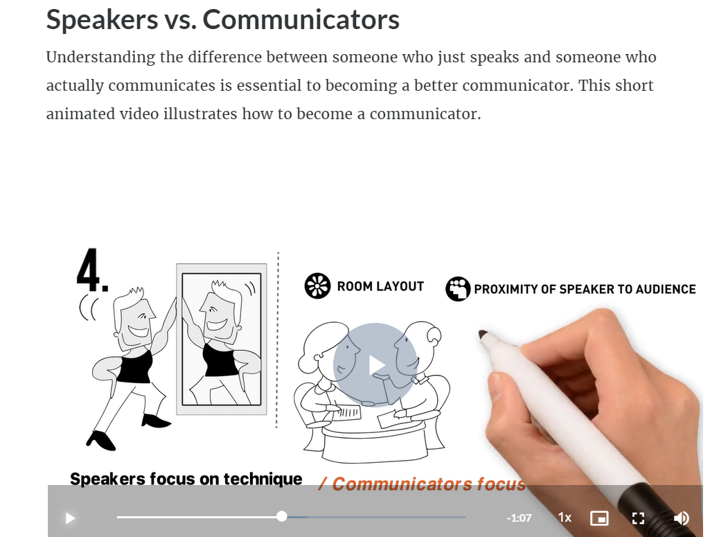
An example of a learning event in our Leading Edge Learning modules. The types of instructional content within the modules include: readings, videos, transcripts, audios, interactive questions, offline application exercises, flash cards, narrated presentations, matching exercises, relevant articles, downloads, a final exam, and other activities designed to engage learners based on recognized science of learning educational concepts.
Applications and Best Practices
- Improve communication skills of undergraduate or graduate students.  - Integrate in a course on management communication.  - Include as a resource in a career center for workplace skills development. |  | - Integrate into an existing course or program in management or leadership.  - Develop skill sets of working professionals.  - Teach English communication skills to non-native speakers.
Pricing
Module is Approximately 3-5 Learner Hours
1-100 Learners per Year | 101-500 Learners per Year |  | 500+ Learners per Year
$49 per Learner | $44 per Learner |  | $39 per Learner

